**Multiplexer 4:1 using Structural model**

**1. code**

---------------------------------------------------------------------------------

library IEEE;

use IEEE.STD_LOGIC_1164.ALL;

use IEEE.STD_LOGIC_ARITH.ALL;

use IEEE.STD_LOGIC_UNSIGNED.ALL;

entity multiplexer_s is

Port ( a,b,c,d,s0,s1 : in STD_LOGIC;

x : out STD_LOGIC);

end multiplexer_s;

architecture structural of multiplexer_s is

COMPONENT AND_GATE

PORT( a,b,c : IN STD_LOGIC;

d : OUT STD_LOGIC );

END COMPONENT;

COMPONENT NOT_GATE

PORT( a : IN STD_LOGIC;

b : OUT STD_LOGIC );

END COMPONENT;

COMPONENT OR_GATE

PORT( a,b,c,d : IN STD_LOGIC;

e : OUT STD_LOGIC );

END COMPONENT;

SIGNAL t1,t2,t3,t4 : STD_LOGIC;

SIGNAL s0_bar,s1_bar : STD_LOGIC;

BEGIN

U1 : NOT_GATE PORT MAP (s0, s0_bar);

U2 : NOT_GATE PORT MAP (s1, s1_bar);

U3 : AND_GATE PORT MAP (a, s0_bar, s1_bar, t1);

U4 : AND_GATE PORT MAP (b, s0, s1_bar, t2);

U5 : AND_GATE PORT MAP (c, s0_bar, s1, t3);

U6 : AND_GATE PORT MAP (d, s0, s1, t4);

U7 : OR_GATE PORT MAP (t1, t2, t3, t4, x);

end Structural;

**Program Added as a source for AND_GATE**

----------------------------------------------------------------------------------

library IEEE;

use IEEE.STD_LOGIC_1164.ALL;

use IEEE.STD_LOGIC_ARITH.ALL;

use IEEE.STD_LOGIC_UNSIGNED.ALL;

entity AND_GATE is

Port ( a,b,c : in STD_LOGIC;

d : out STD_LOGIC);

end AND_GATE;

architecture Behavioral of AND_GATE is

begin

d <= a AND b AND c;

end Behavioral;

**Program Added as a source for OR_GATE**

library IEEE;

use IEEE.STD_LOGIC_1164.ALL;

use IEEE.STD_LOGIC_ARITH.ALL;

use IEEE.STD_LOGIC_UNSIGNED.ALL;

entity OR_GATE is

Port ( a,b,c,d : in STD_LOGIC;

e : out STD_LOGIC);

end OR_GATE;

architecture Behavioral of OR_GATE is

begin

e <= a OR b OR c OR d;

end Behavioral;

**Program Added as a source for NOT_GATE**

library IEEE;

use IEEE.STD_LOGIC_1164.ALL;

use IEEE.STD_LOGIC_ARITH.ALL;

use IEEE.STD_LOGIC_UNSIGNED.ALL;

entity NOT_GATE is

Port ( a : in STD_LOGIC;

b : out STD_LOGIC);

end NOT_GATE;

architecture Behavioral of NOT_GATE is

begin

b <= not a ;

end Behavioral;

**2. RTL Schematic**

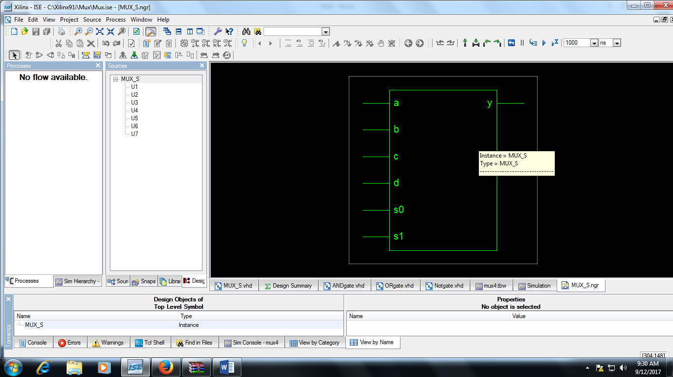

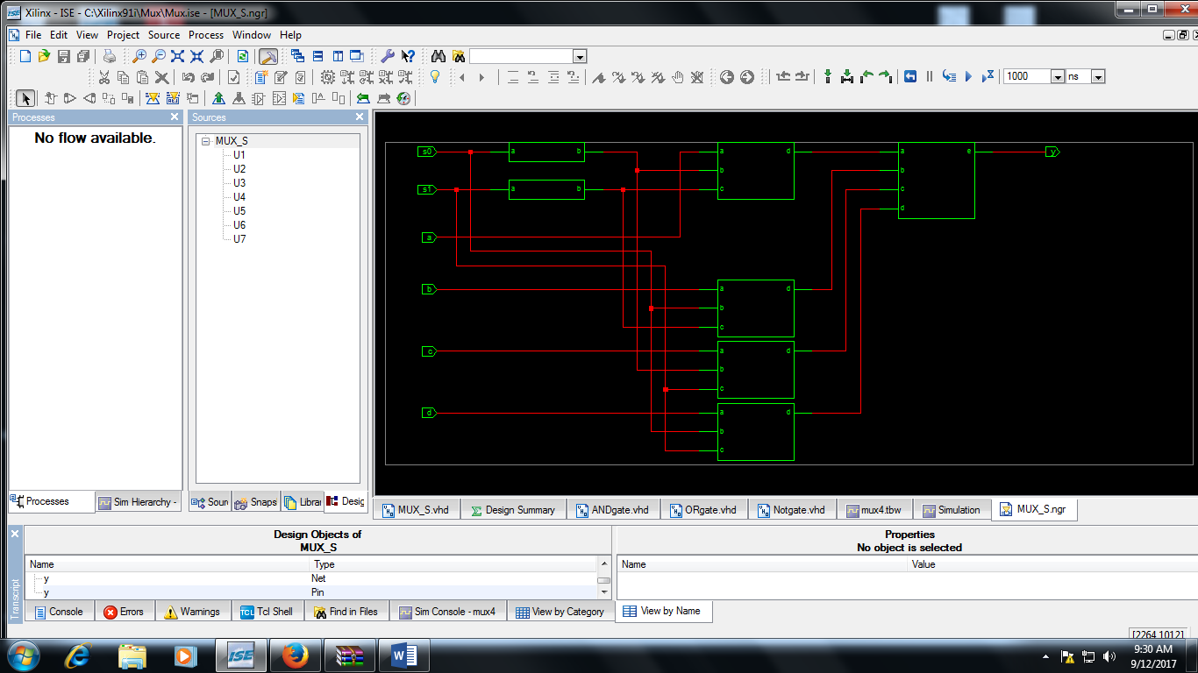

**3. Simulation Output**

